THE SMART PARKING MANAGEMENT SYSTEM

INTRODUCTION

The number of car client’s increases was requested more parking spots, and with the growth ofthe internet of things causes smart urban areas to have picked up grind popularity. In this way, issues, for example, traffic blockage, constrained vehicle leaving offices, and street security are being tended to by IoT. So, several parking organization systems have been organized to decreasesuch traffic issues and improve the comfort of car users, it has combined

SMART PARKING SYSTEM

One of the most important problems facing large cities is congestion and parking . So, usingAutomated Parking System Management is an efficient technique using the Internet of Things tomanage the garage . Smart parking is an electronic tool that enables the user to find vacantparking spaces through information technology and by using appropriate sensors

LITERATURE SERVEY

In this section, some related works of smart parking are presented. The System was used sensors, technologies, and interfaces to collect and display information in real-time, which required expensive private infrastructure. The smart parking system delivered user information and accessibility of parking slots through the VMS on the internet. It was classified into off-road and on-road. Google map application, ultrasonic sensors, and cloud-stored data wereused in Smart parking, the Android application map forward data of the empty place of the user.

IMPLEMENTATION & WORKING

The Proposed System Finding a place to park cars involves three-stage. First, the parking area which has Arduino devices along with the sensors to interact between the user and the parking area

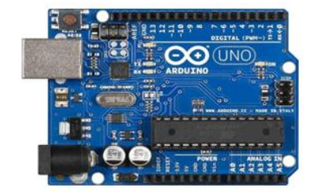Hardware Components& Circuits

System Initialization

In the initial stage, a certain number of images are captured and their average is calculated to make an averaged background reference image. This reference image does not contain any cars. The main purpose is to identify the parking slots in the image. The camera which is used to take the images is fixed at a certain position and it faces a fixed direction all the time.

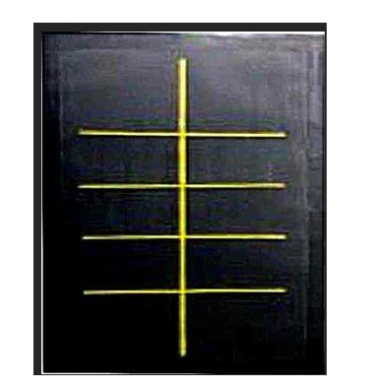

Five steps are used in web applications

• Installing Apache Web server

• Create My SQL database system

• Developed web application For the GUI (Graphical User Interface)

• Write lots of PHP, JAVA script, CSS and Python Programs for the Web Application

• Host Web application on our Web server IOT can help to perform any desired action like controlling a device

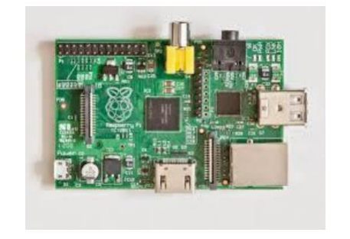

**Software programming**

MAIN.py

import schema

import state

import time

#create connection

schema.InitConnection()

#create database

schema.InitDB()

#check if the database has a lot by the name "Swargate". Number of rows matching the address is

returned.

lots = schema.ParkingLot.selectBy(address = "Swargate")

#if there is no lot by the name "Swargate", create a lot.

if lots.count() == 0:

lot = schema.CreateLot("Swargate", 3, 50, "Enter_bolt_cloud_access_token")

else:

lot = lots[0]

#set the sensor of a parking lot.

schema.SetSensor(lot, 2, 1, "Enter_bolt_device_id")

#loop for checking and displaying number of empty spaces on each floor every 10s.

while True:

state.CheckAll()

for floor in lot.floors:

print("Empty spaces on floor ", floor.fid, ":", floor.freeSpaces)

time.sleep(10

OUTPUT:

Debug Log Output

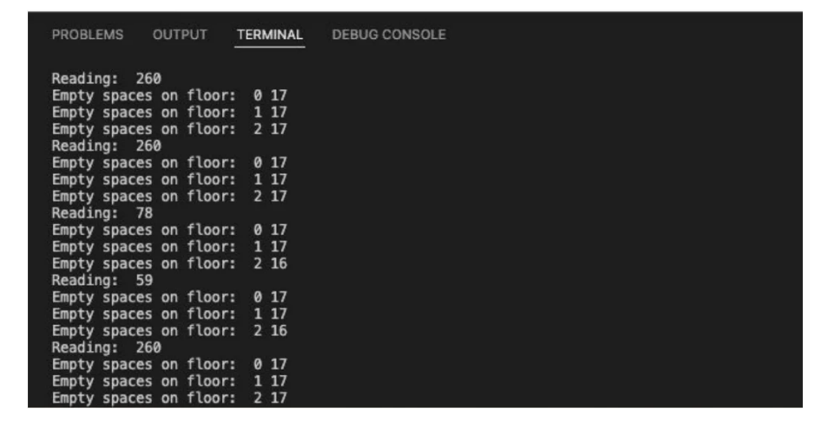

Conclusion:

● Automated IoT based system

● Number of free spaces displayed

● Glowing LED to indicate presence of empty spot

● Database updated every 10 seconds

● Manual assistance eliminated

● Time wastage eliminate

EXPERIMENTAL RESULT

An intelligent parking lot detection system based on image processing have been tested and proposed in this paper. This results are included the sequences of the car park detection from empty lot (10 parking available) until the full parking lot. The system shows the number of availability of parking

C**ONCLUSION**

The parking space detection system based on image processing in MATLAB was designed and tested. It is possible to manage large area by just using several cameras